HYGIENE FRIENDLY HOME INSPECTIONS

Do not enter homes if you:
- Have tested positive to COVID-19
- Have been in contact with infected persons
- Have returned from overseas in last 14 days
- Have flu-like symptoms

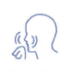
Good Practice:
If you are coughing or sneezing, use a tissue or
cover your mouth and nose with your elbow not
into your bare hands.

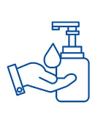
Use Hand Sanitiser:
Please DO use hand sanitiser provided (where available)
and avoid touching surfaces wherever possible

Avoid Physical Contact:
Please avoid physical contact with one another
- Including shaking hands
- Social Distancing (1.5m)

Westons Property & Co. appreciates the community’s efforts during this time.
Thank you.

